**LinkedInsights Design Choices**

Avril Mauro, Dennis Ho, Esther Ho

Website Link:

<https://avrilmauro.github.io/LinkedInsights/index.html>

## 

## **U.S. Job Market Map: Salary, Sector, and Skills by State and County (2023–2024)**

For our map diagram, we wanted to be able to depict compensation on the state and county level. To do this, we used a toggle functionality as well as distinct color palettes (plasma for counties and viridis for states) to differentiate between the two. The two color palettes chosen have strong contrast, allowing for easy view when overlapped. For the county level data, we adjusted the threshold to accommodate the wider salary range. We also reduced layer opacity so that a user could view both layers of data, allowing for better data comparison. To further enhance the viewing experience, we restricted zoom interaction to just the mainland USA and Alaska/Hawaii. We implemented tooltip functionality to show only state/county name and average salary upon hover. Upon clicking, the tooltip showed more information that may be helpful to the user (median salary, top sector, total jobs, % jobs in the top sector, top 3 skills). Making use of Folium’s interactive elements on the subtle CartoDB background helped to minimize visual distraction, while maintaining state borders and major city markers.

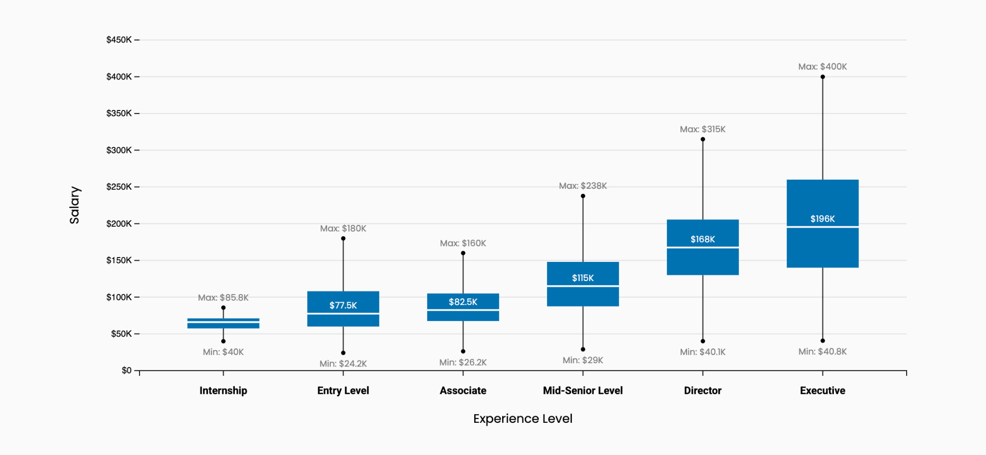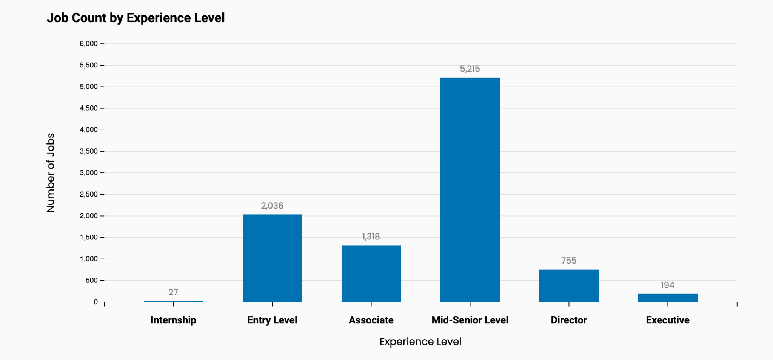

## **U.S. Job Market Box Plot: Salary Distributions Across Experience Levels (2023-2024)**

To maintain visual consistency with the website, we used LinkedIn Blue (#0072b1) for the boxes, helping to reinforce the overall user experience. The slightly off-white background enhances contrast and improves the visibility of the median line, making key statistics easier to interpret at a glance. We opted for horizontal grid lines only, using minimal styling to provide subtle reference points without distracting from the primary data. Min/max values are labeled in grey to establish a clear visual hierarchy, drawing attention to the median, the most statistically significant data point. Dots on the endpoints mark the range boundaries, helping users quickly grasp data distribution. The dollar values are consistently formatted with appropriate rounding, maintaining accuracy for smaller amounts through decimal places while simplifying the overall number presentation. Finally, the experience levels are ordered by typical career steps (intern up to executive), making it easy to follow how salaries grow over time.

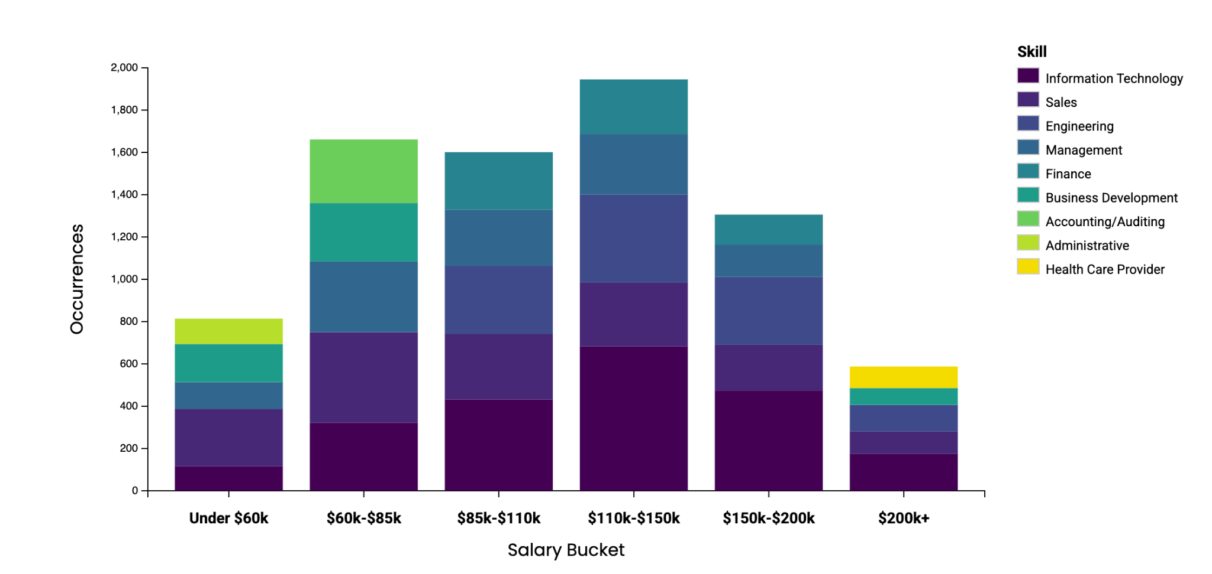

## **U.S. Job Market Bar Plot: Top 5 Skills Across Salary Ranges (2023-2024)**

We used "k" notation to signify thousands for dollar values to make the numbers quicker to read and to save space on the chart, reducing overlap of the labels. To help users immediately see the count of jobs with that skill, we placed white data labels directly on each bar, so there’s no need to look back and forth between an axis. We assigned each skill category a distinct color, not just for readability, but to also ensure the chart is accessible to users with trouble viewing non-distinct colors. To keep the visualization clean, we moved the legend outside the chart area, making it easy to reference without adding clutter. We also formatted the Y-axis with commas for values over 1,000, which helps with quick number recognition. The bars for each salary bucket were made wider to better use the available space and reduce empty gaps. Finally, we ordered the skill categories by frequency, placing the most common ones at the bottom to create a clear visual hierarchy and highlight the most important trends.

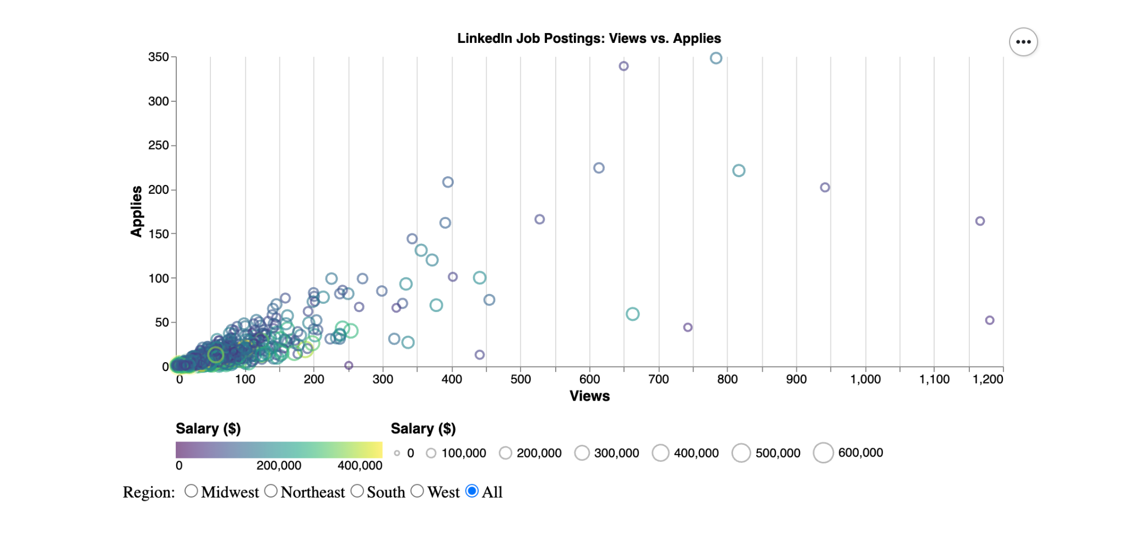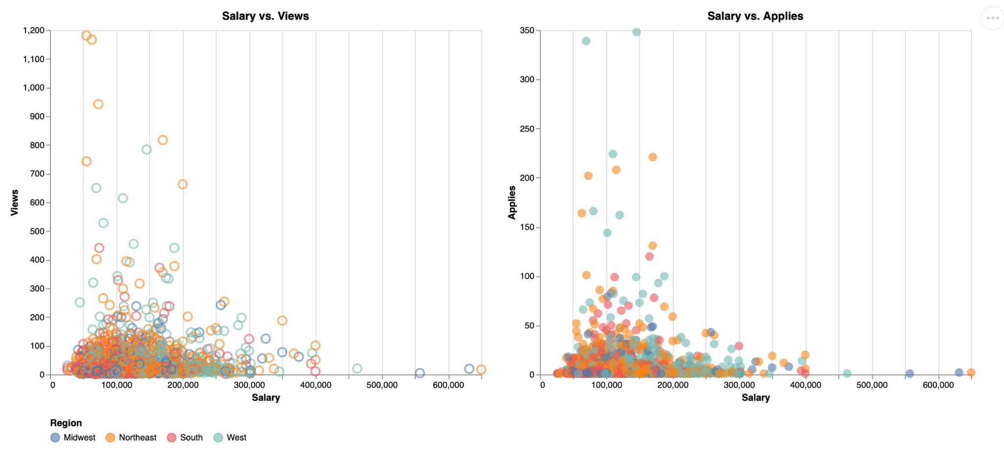

## **U.S. Job Market Scatter Plot: Job Impressions by Salary and Region (2023-2024)**

To clearly distinguish between Views and Applies, we used different mark types, allowing users to quickly compare these related metrics. Region-based color coding was used to highlight geographic trends with radio button filtering and highlighting function enabling users to focus on specific areas/timelines of the data for the applied filter view. Visually distinct colors were chosen for each region to support quick and easy comparison of job market activity across locations. We used only vertical grid lines with subtle styling to provide helpful reference points for salary values without distracting from the rest of the data. Large numbers in the thousands were also formatted with comma separators here to improve readability at a glance. To keep the visualization clean while still offering depth, we selected visually distinct colors for each region, allowing users to quickly identify patterns in job market activity that may be isolated to individual regions.

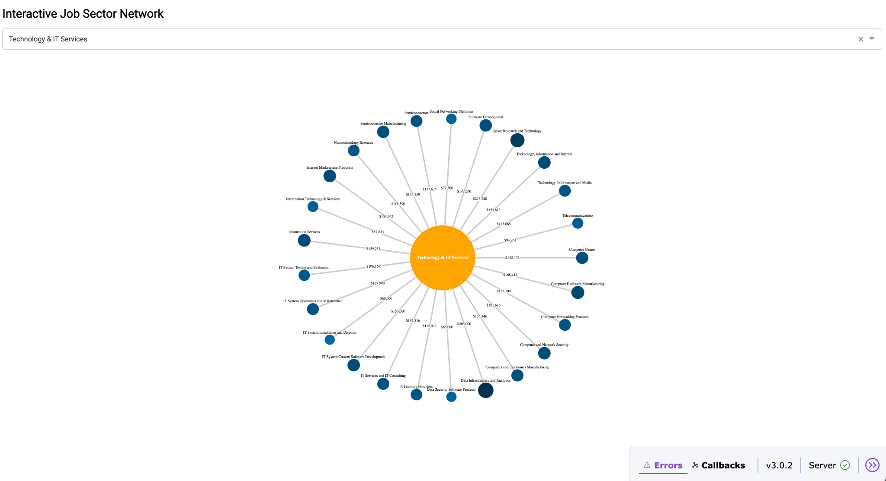

## **U.S. Interactive Job Sector Network (2023–2024)**

**NOTE: this graph only displays on the website when the server is running on Render.com, alternatively you can view it if the file network.py is ran**

To keep things clear and manageable with such a large dataset, we added dropdown interactive filtering by sector. This helps users avoid information overload by letting them focus on specific parts of the postings that are relevant to them. We stuck with the LinkedIn Blue (#0072b1) for the base color of the industry nodes to maintain overall site consistency, while changing up the shade of that blue to represent salary levels. Darker shades indicate more higher-paying sub-industries, making them stand out at a glance. Node sizes also reflect salary values, but we scaled them carefully to preserve the overall star-shaped layout, so the structure stays balanced and easy to follow. We chose the star layout because it helps visually show how each industry connects back to its parent sector. To make the visualization more cohesive, we used the standard yellow from the website’s palette for the central sector nodes, creating strong contrast against the blue and drawing attention to the core relationship connecting the sub-industries. We also labeled the connecting lines with their corresponding salary figures, allowing users to easily compare industries within each sector.